**Semester 2 (Units 3 and 4) Examination, 2016**

**Question/Answer Booklet**

**MATHEMATICS METHODS**

**Section One: Calculator-free**

Student Name/Number: ______________________________________________

Teacher Name: ______________________________________________

**Time allowed for this section**

Reading time before commencing work: five minutes

Working time for this section: fifty minutes

**Materials required/recommended for this section**

**To be provided by the supervisor:** This Question/Answer Booklet

Formula Sheet

**To be provided by the candidate:**

Standard items: pens (blue/black preferred), pencils (including coloured), sharpener, correction fluid/tape, eraser, ruler, highlighters

Special items: nil

**Important note to candidates**

No other items may be taken into the examination room. It is **your** responsibility to ensure that you do not have any unauthorised notes or other items of a non-personal nature in the examination room. If you have any unauthorised material with you, hand it to the supervisor **before** reading any further.

**Section One: Calculator-free (54 Marks) Weighting 35%**

This section has **10 (ten)** questions. Answer **all** questions. Write your answers in the spaces provided.

Suggested working time: **50 minutes**.

**Question 1 (6 marks)**

Determine the exact value of m, , for each of the following equations.

(a)  (2 marks)

(b)  (4 marks)

**Question 2 (9 marks)**

(a) Differentiate each of the following with respect to . Do **not** simplify your answers.

(i)  (3 marks)

(ii)  (3 marks)

(b) Show how to use the chain rule to determine  when  (3 marks)

**Question 3 (3 marks)**

Describe each of the following as either a discrete random variable, a continuous random variable or a non-random variable.

(a) the number of dots showing on a die after being thrown. (1 mark)

(b) the distance between Sydney and Melbourne. (1 mark)

(c) the thickness of wire coming off a production line. (1 mark)

**Question 4 (4 marks)**

Determine the value of k if represents a probability density function.

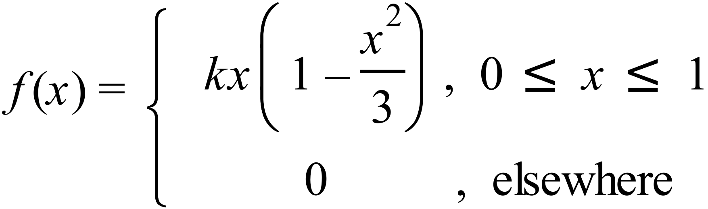

**Question 5 (4 marks)**

The probability density function for a Bernoulli distribution is:

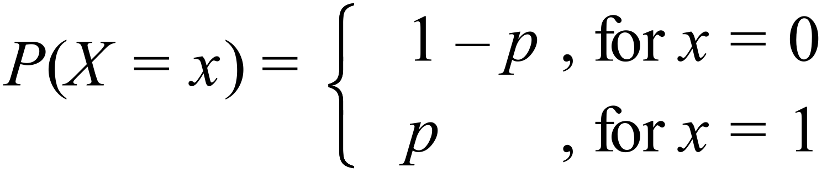

Given that the standard deviation for a particular Bernoulli distribution is 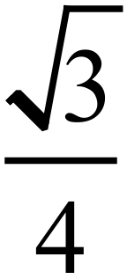 , determine the value(s) of p.

**Question 6 (4 marks)**

Consider the graph of 

(a) For what values of x is the function valid? (1 mark)

(b) Determine the -coordinate of the point on  where the slope of the tangent is 4.

(3 marks)

**Question 7 (4 marks)**

The probability density function of a discrete random variable Y is given by

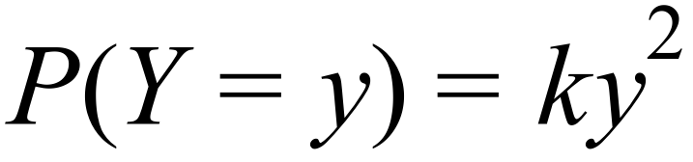 , for 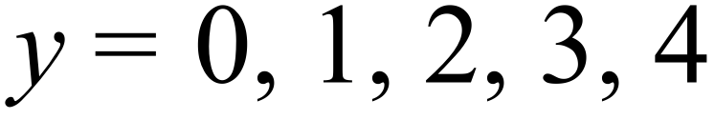 .

(a) Complete the probability distribution for Y (2 marks)

|  |  |  |  |  |  |
| --- | --- | --- | --- | --- | --- |
| y | 0 | 1 | 2 | 3 | 4 |
|  |  |  |  |  |  |

(b) Determine the value of k. (2 marks)

**Question 8 (3 marks)**

Given . If  and  determine .

**Question 9 (12 marks)**

When calculating a confidence interval for a population proportion from a sample an associated z score is used. Use the table below to answer the following questions:

|  |  |
| --- | --- |
| Confidence Interval | **z score (rounded to 1 decimal place)** |
| 95% | 2.0 |
| 87% | 1.5 |
| 68% | 1.0 |

(a) In a random sample of 100 people, 20 said they had watched an AFL game in the last year.

(i) Determine the proportion of those in the sample who had watched an AFL game in the last year (1 mark)

(ii) Determine a 95% confidence interval for the proportion of the population who had watched an AFL game in the last year. (4 marks)

A random sample of size  was taken and the proportion of people who had watched a game of AFL in the last year was .

(b) Determine a 68% confidence interval for the proportion of the population who had watched an AFL game in the last year in terms of  and . (2 marks)

(c) A new sample of size  was taken and the proportion of people who had watched a game of AFL in the last year was again. When an 87% confidence interval was determined it was found to be the same as the interval determined in part (b).

(i) Is  larger or smaller than ? Explain (2 marks)

(ii) What is the relationship between  and ?  
 (3 marks)

**Question 10 (5 marks)**

The graph of  is shown below. It consists of two straight lines followed by a curve. The area between the function and the *x*-axis is equal to 50 square units.

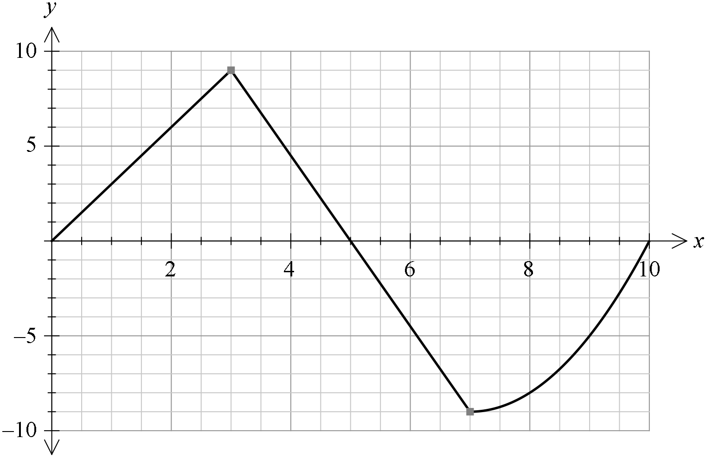

1.  (2 marks)

1.  (3 marks)

**End of Questions**